# **INFO6028 – Graphics 1 - Mid-term Exam – Fall 2017**

Instructor: Michael Feeney

## The exam format:

* You may use any resources you feel are necessary to complete the exam, but you are to answer the questions **on your own**. I will be looking for plagiarism (i.e. copying) very carefully. There is *no possible way* that the specific code to answer these questions, or the output to the screen, would be very similar to the look of another student’s code. Remember, this is a test and there are very clear policies about cheating on tests.   
  + <http://www.fanshawec.ca/admissions/registrars-office/policies/cheating-policy>
  + <http://www.fanshawec.ca/sites/default/files/assets/Ombuds/cheating_flowchart.pdf>
* The questions are ***NOT*** of equal weight. There are eight (8) pages with seven (7) questions
* The answers may be one or a combination of the following:
  + Short answer (in your own words)
  + Snippets of code
  + Complete running solutions
* CLEARLY indicate which answer goes to which question. My suggestion is that you place each answer in its own folder, named “Question_01”, “Question_02” and so on (or something equally clear). Another option is to create a Visual Studio solution and add a number of projects – one per question – to it. If I can’t make heads or tails of what question is what, I probably won’t even mark it.
* Place any written answers into a Word, RTF, or text file. Again, *clearly* indicate which question you are answering.
* If you are combining answers (which is likely), please indicate this with a “readme” file or some note (*not* buried in the source code somewhere).
* For applications: if it doesn’t build and run, *it’s like you didn’t answer it*. I’ll correct trivial, obvious problems (like you clearly missed a semicolon, etc.), but you need to be sure that it compiles and/or runs.
* You have until **11:59 PM** on **Thursday, November 30th** to submit all your files to the appropriate drop box on Fanshawe Online.   
    
  **NOTE:** Although this may “look and feel” like a project, it isn’t, it’s an **exam**, so there is **no concept of “late marks**”; if you don’t submit your files by 11:59 PM, you don’t get any marks at all. *Don’t Be Late submitting.*

(Also be **SURE** that you are actually submitting the correct files)

* You can reach me through e-mail ([mfeeney@fanshawec.ca](mailto:mfeeney@fanshawec.ca)) or by calling the school.
* There is also a **Battlestar_Galactica_PLY.7z** file you will need. It’s available on FOL with the mid-term.

## Questions:

About ten years ago, the original, epic 1970s TV show “Battlestar Galactica” was re-imagined. I’m not sure what “re-imagined” really means, but I’m guessing it must mean “turn it from being cheesy and sucking to super freaking awesome”.

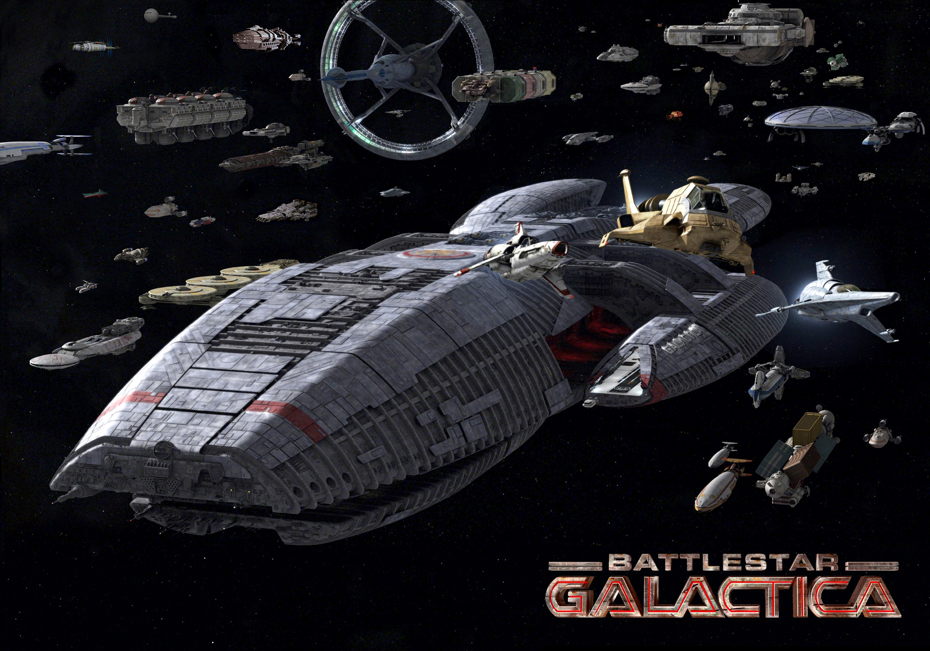

(From: <http://pressstart2begin.files.wordpress.com/2013/08/galactica.jpg>)

If you’ve never seen the show, he’s some footage that capture the excitement of the “space battle” scenes: <https://www.youtube.com/watch?v=czAzLP19_9Q>. So many explosions!   
(called “Battlestar Galactica EPIC Battle Montage” on YouTube)

(And if you are a Star Trek fan-boy/girl, check out this cool, but super strange video: <http://www.youtube.com/watch?v=efgDdSWDg0g>, called “Galaxy Class USS Enterprise (NCC-1701-D) vs Cylon Basestar ships of Battlestar Galactica”)

For this exam, you will be recreating various scenes from this “new” TV show.

If you’ve never seen the show, here’s a very brief, very simplified summary:

* Humans = The “Good Guys”
  + Battlestar Galactica (the big ship in the picture above) is sort of an “aircraft carrier in space”, but it has big guns, too (lots of big guns, actually).
  + The two little ships flying to the right are a “Raptor” (gold coloured one) and a one man fighter called a “Viper”.
* Cylons (aka “evil robots”/cyborgs) = The “Bad Guys”
  + They have their own “aircraft carriers in space” called a “Base Star”. There’s two types: a “two wheels, one on top of each other” version, and a “two triangle-sort-of shapes, one on top of each other” (about 35 sec. in to the 1st video you see both)
  + These “Base Stars” are filled with little bat-like ships called “Raiders” (at about 31 sec. seconds in, you can see swarms of them coming out of a Base Star)

Sizes:

* The Viper is a one man ship, about 9 meters (30 feet) long.
* The Raider is about 1/2 to 2/3 the size of the Viper.
* The Galactica is way, WAY, ***WAY*** bigger... like several kilometers long

Here’s a good comparison web page: [http://www.sciencefictionmodels.com/reference-material/battlestar-galactica-size-comparison-charts/](http://www.sciencefictionmodels.com/reference-material/battlestar-galactica-size-comparison-charts/%20%20)

NOTE: I’m going for “good enough” sizes, **not** *precise* sizes (it’s a made up, imaginary show. I know, I know, it’s very sad, but it’s just pretend. Get over it.), HOWEVER, if you show me a Galactica that’s, like, 10x the size of the Viper, *you’re going to lose marks* (it’s something like 100x bigger at least, more like 1000x bigger than a Viper).

|  |  |
| --- | --- |
|  | Older (left) and newer style Viper ship. It’s a one person ship, so imagining someone in the “cockpit” (pilot’s seat) – the glass bit – gives you a sense of the size. They are both pretty much the same size  These are HUMAN ships. |
|  | Older (left) and newer Cylon ships. The old ones were piloted by 3 Cylon Centurians, that were humanoid and about the size of human, whereas the newer is actually a robot (well, technically a cyborg). |
|  | The Battlestar Galactica. It’s *freaking* huge, something like 2 km (yes 1000 m) long. As you can see from the video, the small pods on either side are actually comparable in size to an Earth aircraft carrier. |

The “**Battlestar_Galactica_ply.7z**” file contains some PLY models that you are to use.

**\*\*\* WARNING \*\*\***

The original Batlestar Galactica model is **HUGE** (> 70 Mbytes and contains almost a million triangles!). **Don’t** use this while you are working on the questions. Instead, use one of the *simplified* Galactica models (there’s a number of them there, all the same size, just fewer triangles – not that as they get smaller, they simplification/normals sort of breaks down, so the lighting won’t look nearly as great with fewest triangle versions).

These very large files are only there **if** you want to see everything in super high resolution **WHEN YOU ARE ALL DONE**.

My point: if I hear “*Mr. Feeney, it took /soo/ long to load the model that I didn’t get the exam done!*” I’m just going to roll my eyes and mark your exam as is.

Ideally, I’d like to use the higher resolution models, so I will just look in your submission and replace the lower resolution models with the higher resolution ones...

...but you **CAN** edit the lower resolution models if you feel that’s going to help you, so if you do edit the models, please let me know.

1. (20 marks) Make a scene: You are to recreate a scene with at least two dozen “Raiders” (cylons) coming in for an attack on the Galactica, with at least a dozen “Vipers” (good guys) coming out to meet them (the Raiders). Use your discretion when placing the camera, but you should be able to see all the models. The “Raiders” should be flying in a perfect formation (they are robots, so that’s expected), but the “Vipers” should be in a more disorganized arrangement. Something like this (when viewed from above, but you *can’t* place the camera directly above the scene. Also note that the scale in this picture is very incorrect as the Galactica would be WAY bigger):

(From: <http://imageshack.com/f/p5aMES7Yj> and <http://media-cache-ec0.pinimg.com/736x/e7/b4/ba/e7b4ba985bbc819f0a702f5088c9183a.jpg>)

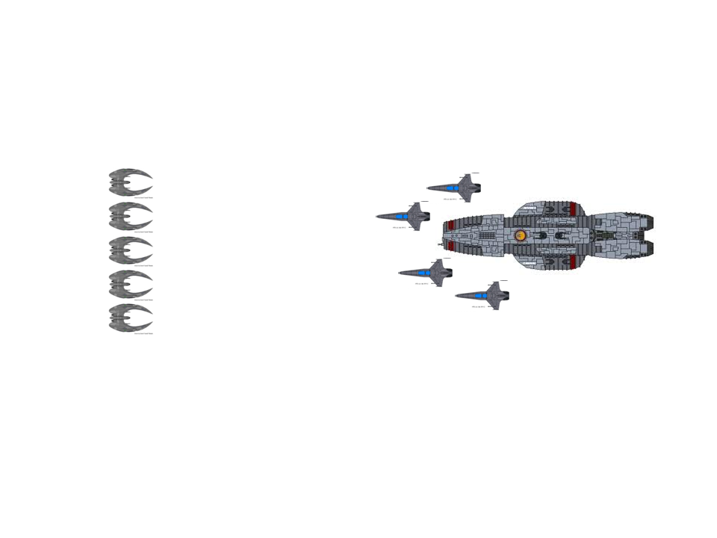

1. (20 marks) Place lights in the engines and landing bay of the Galactica, (sort of) like in the picture, below (one point light per engine, two (much dimmer) point lights per landing pod, inside the landing pods, one near the front and one near the back, so that you can see the triangular landing bay):

(From: http://static.comicvine.com/uploads/original/14/145093/3131325-0256062161-Battl.jpg)

Q3: “Bridge” camera goes around here:

Engine

Landing bay:

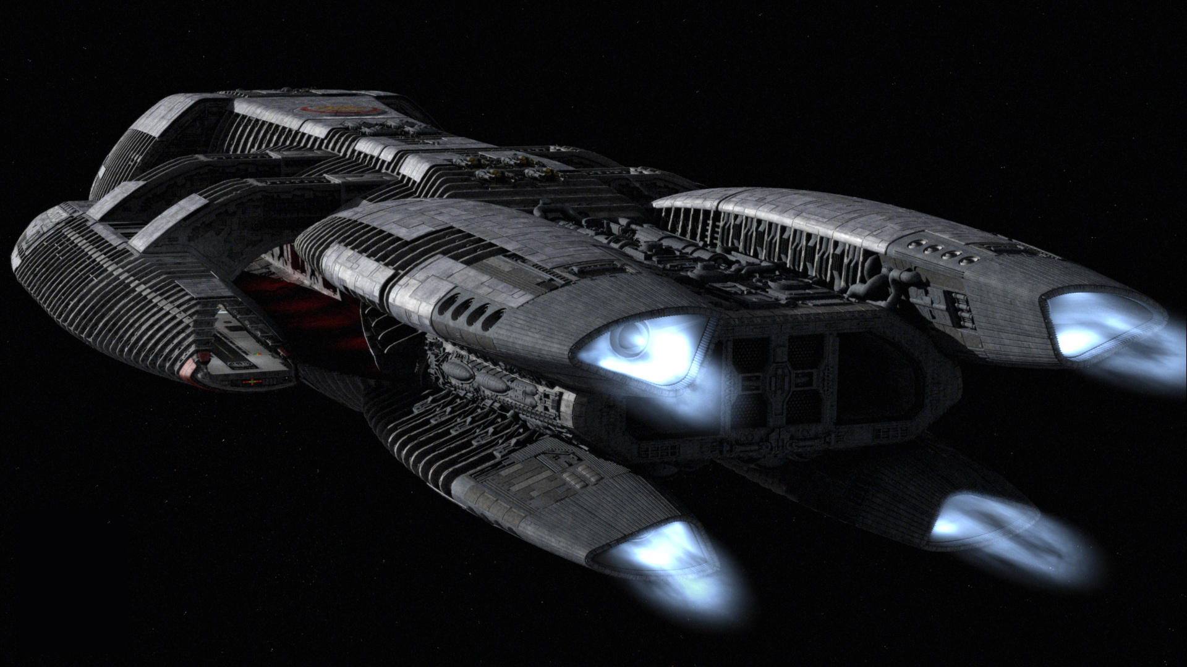

1. (20 marks) Placing the camera over the “bridge” of the Galactica (the “nose” at the front has the “bridge”... somewhere, I guess, so maybe over that round emblem on the top, near the front). By pressing “P” key, the camera “looks at” each fighter/raider in turn (place the camera so that you can always see part of the Galactica). In other words, each time the “P” key is pressed, we change to the “next” ship to look at. When we’ve seen them all, return back to the first one. If you really feel you need to, you can move the camera eye, but I *don’t* want the camera eye moving *every* time. So pick a location of the camera that allows the *least* movement of the camera (not the target) – ideally, the camera shouldn’t move, though.
2. (15 marks) Press a button so that the Raiders “fly towards” the Galactica (in a straight line, and in “formation” – remember, they are robots, so would fly in perfect formation). They don’t have to reach the Galactica. In other words, when you press the button, they start to move (i.e. animate) towards the Galactica. This should take at least 5-10 seconds.   
     
   Place and/or move the camera so that this is clearly visible. You can even move the camera *with* the cylons (or something like that) if you feel that would be easier to visualize.
3. (20 marks) The Vipers launch from inside the “pods” on the side. Press a button to “move” a Viper behind the Galactica, then by pressing (and holding) another button, have it “fly in for a landing” on the landing bay. The camera should be “looking out” the front of the Viper (so I should be always be able to see part of the Viper, like the nose, or something, as if you are looking out from the cockpit). The camera should move (i.e. animate) during this process – in other words, I’m not asking you to immediately “jump” (instantly place) the camera in the landing bay, but to smoothly animate/move there, over time. It should take 5-10 seconds for this to happen.
4. (25 marks) There is a an alternative set of the same models, but using a different format from ply. Since I’m “so creative”, I’ve called the format “ply_x” (i.e. they are text files, with the file extension “ply_x”). Alter your application so that you can use these models instead of the ply models.

The “ply_x” format is as follows:

|  |
| --- |
| NumberOfTriangles = 5372  0 1 2  Triangle #0, #1, #3 (vertex index in order, like in ply)  0 3 1758  0 4 1759  *... (and so on)...*  Vertex #0:  Position z, y, x  Normal z, y, z  NumberOfVertices = 6372  -0.252972 0.0581265 1.872e-005  -1 0 0  -0.252972 0.00122614 -0.0299871  Vertex #1:  -0.697599 -0.234104 -0.677163  *...(and so on)...*  0.434137 0.00111179 -0.257119  Vertex #6371 (last vertex):  0.0656682 0.917862 -0.39143  EndOfFile |

1. (20 marks) Depending on the shader you are using, *add to* or *alter* it so that it passes an “overriding” colour as four float values. In the shader in class, we passed this colour value as a vec3 or vec4, so in the fragment shader, it something like:

|  |
| --- |
| uniform vec4 materialDiffuse; |

If you recall, this overrides the colour being passed through the vertex buffer. This colour value is being passed to the fragment shader through the “out vec3 color;” line.

Replace this variable with something like this (i.e. each element of the vec4 is separated into a single float variable):

|  |
| --- |
| uniform float materialDiffuse_r;  uniform float materialDiffuse_g;  uniform float materialDiffuse_b;  uniform float materialDiffuse_a; |

*In other words, you are changing the uniform colour from a single vec3/vec4 to four discrete float uniforms.*

Alter your application to use this new shader.

(That’s it for the exam).